Winter & Spring 2022/ 2023
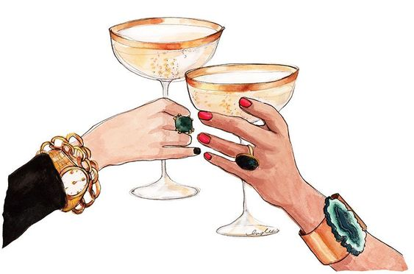

Welcome Cocktails
Seasons Pear-Bellini: Bartenders Ball original…
Sparkling Wine, Pear-pulp* with cardamon, cinnamon and macis
Look: cloudy, served in a Champagne-glass

French 75 or Austrian 65/68:
French Champagne or Austrian Sparkling Wine, fresh lemon juice*, cane sugar syrup*
& a drop of Gin
Look: cloudy, served in a Champagne-glass (the Champagne version we charge additionally)
Mastiha-Bellini: (Bartenders Ball original)
Sparkling Wine, Mastiha (original greek liquor), clove-infused Aperol*, & fresh grapefruit juice*
Look: light red, served in a Champagne-glass

Scroppino Tropicale: Bartender’s Ball original
Sparkling Wine, lemon-sorbet, fresh lemon juice*, passion fruit syrup
Look: bright & white - very tasty in a Champagne-glass

Basil-Fragolino:
Sparkling Wine, strawberry-basil pulp*, elderflower syrup, fresh lime juice*
Look: deep red, served in a Champagne-glass

Non alcoholic Cocktails

Raspberry Rock:
Raspberry-pulp*, limes, Ginger Beer
Look: deep red, served in a Caipirinha-glass, topped with crushed ice

Little Cucumber:
Fresh cucumber-juice*, cardamon syrup*, Ginger Beer, fresh lime juice*, pepper
Look: dark green, served in a Caipirinha-glass

Bergamot Virginia:
Mint, bergamot-essence, cane sugar syrup*, fresh lime juice*, soda
Look: Mojito-green, served in a Longdrink-glass

Coconut Kiss:
Pineapple juice, fresh orange juice, coco-cream*, grenadine
Look: Tropical, served in a hurricane -glass

Beetroot:
Beetroot juice, 100% pineapple juice, slices of fresh ginger (muddled),
fresh lime juice*, Wild Berry-lemonade
Look: very deep cinnabar red, served in a Caipirinha-glass

Signature Cocktails:

Hot Buttered Rum:
Dark Rum, spiced-butter*, oat-milk
Look: caramel, served hot in a tea cup.

Bangkok Vodkatini:
Vodka, Triple Sec orange liqueur, elderflower syrup, fresh lime juice*, fresh coriander
Look: cloudy-green, served in a Martini glass – a twist to the popular classic cocktail

Franke:
3y gold Rum, cane sugar syrup*, fresh mint, fresh lime juice *, bergamot essence
Look: an earl grey mojito, served in a Martini-glass

Opium!
Vodka, poppy seed-tonka bean syrup* fresh passion fruit, fresh lime juice*
Look: like opium, served in a Martini-glass or on the rocks in a tumbler

14 hours ahead! (unlike anything you’ve ever tasted)
Gin or Tequila Blanco 100% de Agave, honey syrup*, fresh lime and lemon-juice* Matcha Powder!, cream & soda
Look: Green, served in a long-drink glass

Winter’s Berry
Bourbon, strawberry, chocolate bitters, orange bitters, honey syrup*
Look: Red, on the rocks, served in a tumbler

Frozen Chilivanilli-Ananasi:
Fresh pineapple, chili-vanilla-syrup*, vodka
Look: martini-glass, frozen white-creamy

White Cinnamon Colada:
Cinnamon Whisky, coconut cream*, 100% coconut water
Look: milky-white, served in a hurricane glass
Persian Beeziness:
Gin, saffron-honey-syrup*, fresh lime & lemon juice *
Look: bright gold with a turmeric-sugar reef, served in a Martini-glass

Classic Cocktails
Negroni and Negroni Winter Edition:
The classic: Gin, Martini Bitters, red Vermouth
Winter edition: a hint of grapes and cinnamon
Look: deep red drink, served in a Tumbler

Martini Cocktail/ Vodkatini:
Gin and/ or Vodka, dry French Vermouth,
Look: Crystal Clear with an olive and/ or an lemon peel, served in a Martini-glass

Cosmopolitan:
Vodka, lime-cordial*, fresh lime juice *, Triple Sec orange liqueur, cranberry juice
Look: light red, served in a martini-glass
Espresso Martini „de la Maison“:
Vodka, espresso*, cardamom-caramel-syrup*
Look: coffee-brown, served in a Martini-glass

Pornstar Martini „de la Maison“:
Lemongrass infused Vodka*, vanilla chili syrup*, fresh Passion fruit, fresh lime juice*
Look: yellow-ish – cloudy in a tropical way. Served in a Martini-glass

Mighty Schokotini:
Vodka, Schoko Noir Liqueur, Rooibos Tee, Karamel Sirup*
Look: Schokoladebraun, served in a Martini-glass

Whiskey Sour:
Rye Whiskey, fresh lemon juice *, fresh orange juice*, cane sugar syrup*
Look: light orange, served in a small tumbler

Mint Julep:
Bourbon, fresh mint, cane-sugar-syrup*
Look: like a little mojito, served in a tin-cup or a tumbler

Mango-Chili Margarita:
Mango-Chili Infused Tequila*, orange liqueur, fresh lime juice*
Look: Cloudy yellow – depends on the Mango… served in a Martini-glass with our house own salt-herbs on the glass’ rim!

Gin Basil Smash:
Gin, fresh basil, fresh lime juice*, cane sugar syrup*
Look: Green-ish, on the rocks, served in a tumbler

Lychee Martini:
Lychee-Pulp*, Vodka, fresh lime juice*
Look: milky-white, served in a Martini-glass

Valentine:
Gin, fresh cucumber, violet-syrup, fresh lime juice *
Look: violet, served in a Longdrink-glass

Moscow or London Mule:
Vodka or Gin, fresh limes, Cucumber, Ginger Beer lemonade
Look: bright green, very light in taste, hint of fresh apple, served in a Longdrink-glass

Thai Message (based on Marco Pani’s Thai Massage):
Infused lemongrass-ginger-gin*, fresh lime juice*, vanilla-honey-chili-syrup*
Look: cloudy yellow, served with a fresh chili in a Martini-glass

Manhattan:
Rye Whiskey, dry vermouth, red vermouth, angostura bitters
Look: Whiskey-brown to red with an orange peel or an amarena cherry

Should you not be finding your favourite Cocktail or flavour on this list, please do not hesitate to inform us. We will tend you with the best possible solution!
All of our Drinks are lactose free and made of freshly pressed citrus fruit juices and premium Spirits!

Yours sincerely!
The Cocktail Crew of
Palais Wertheim, Palais Berg,
and wherever you allow us to be….

www.bartendersball.at

